Name: Munna Chauhan

Reg. No.: CH.EN.U4CSE22176

Lab Exp.: 07

-----------------------------------------------------------------------------------------------------------------------------------

Aim: To implementation of Code Optimization Techniques.

Code:

#include <stdio.h>

#include <string.h>

// Structure to represent an intermediate code statement

struct op {

char l; // Left part (the variable being assigned to)

char r[20]; // Right part (the expression)

} op[10], pr[10]; // op[] stores the original code, pr[] stores the optimized code

int main() {

int a, i, k, j, n, z = 0, m, q;

char \*p, \*l;

char temp, t;

char \*tem;

printf("Enter the Number of Values: ");

scanf("%d", &n); // Read the number of statements (n)

// Input the intermediate code statements

for (i = 0; i < n; i++) {

printf("left: ");

// Assuming single character variable name on the left side

scanf(" %c", &op[i].l);

printf("right: ");

// Reading the expression on the right side

scanf("%s", op[i].r);

}

printf("\nIntermediate Code\n");

for (i = 0; i < n; i++) {

printf("%c = %s\n", op[i].l, op[i].r);

}

// Dead code elimination part

// Copy only statements where the assigned variable (op[i].l) is used in a later statement's right side.

for (i = 0; i < n - 1; i++) {

temp = op[i].l; // Variable assigned in current statement

// Check if the variable 'temp' is used in any subsequent statement's right side

for (j = i + 1; j < n; j++) {

p = strchr(op[j].r, temp); // Search for 'temp' in op[j].r

if (p) {

// If found, this statement is NOT dead. Copy it to the 'pr' array.

pr[z].l = op[i].l;

strcpy(pr[z].r, op[i].r);

z++;

break; // Once found, no need to add duplicates for this statement (op[i])

}

}

}

// Add last statement as it is (it's assumed the result of the last statement is used/printed outside)

pr[z].l = op[n - 1].l;

strcpy(pr[z].r, op[n - 1].r);

z++;

printf("\nAfter Dead Code Elimination\n");

for (k = 0; k < z; k++) {

printf("%c = %s\n", pr[k].l, pr[k].r);

}

// Common subexpression elimination

for (m = 0; m < z; m++) {

tem = pr[m].r; // Right side of the current statement

// Compare with all subsequent statements

for (j = m + 1; j < z; j++) {

p = strstr(tem, pr[j].r); // Check if pr[j].r is a common subexpression in pr[m].r

if (p) {

t = pr[j].l; // Variable assigned by the later common subexpression

pr[j].l = pr[m].l; // Replace the variable of the later statement with the earlier one

// The following inner loop seems intended to update the right sides of other statements

// that might use the later common subexpression (pr[j].l), replacing it with the earlier one (pr[m].l)

for (i = 0; i < z; i++) {

l = strchr(pr[i].r, t); // Search for the eliminated variable 't' in pr[i].r

if (l) {

a = l - pr[i].r; // Position of the character 't'

pr[i].r[a] = pr[m].l; // Replace it with the earlier variable 'pr[m].l'

}

}

}

}

}

printf("\nAfter Eliminating Common Expressions\n");

for (i = 0; i < z; i++) {

printf("%c = %s\n", pr[i].l, pr[i].r);

}

// Remove duplicates by marking them '\0' (This step cleans up the result of CSE)

for (i = 0; i < z; i++) {

// Compare statement i with all following statements j

for (j = i + 1; j < z; j++) {

// Compare the right sides

q = strcmp(pr[i].r, pr[j].r);

// If right sides are the same AND the left sides are the same (e.g., a=b+c and a=b+c)

if ((pr[i].l == pr[j].l) && (q == 0)) {

pr[i].l = '\0'; // Mark the earlier duplicate statement's left variable as '\0' for removal

}

}

}

printf("\nOptimized Code\n");

for (i = 0; i < z; i++) {

// Print only statements that haven't been marked for removal

if (pr[i].l != '\0') {

printf("%c = %s\n", pr[i].l, pr[i].r);

}

}

return 0;

}

Output:

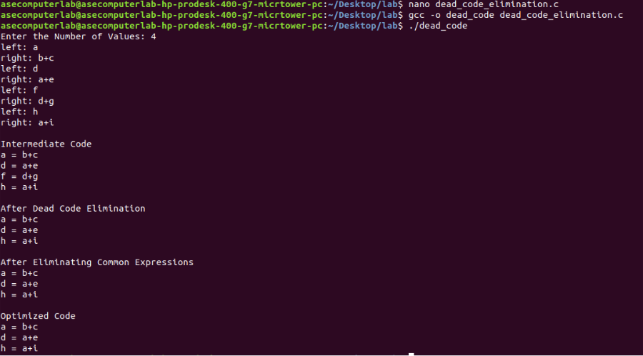

Result: Thus, the program to implement Code Optimization Techniques has been executed successfully.